**Community Annex B Cape Meares**

1 Community Overview 2

2 Existing Evacuation Facilities Analysis 2

3 Evacuation Improvements Project Identification 8

3.1 Wayfinding 8

3.2 Planning 10

3.3 Construction 10

# 1 Community Overview

The Cape Meares area extends from south of the Cape Meares National Wildlife Refuge north along Bayocean Rd to Bayocean Peninsula Park and the Cape Meares spit. The area is defined mainly by residential uses south of the spit and recreation uses in Bayocean Peninsula Park and the spit.

# 2 Existing Evacuation Facilities Analysis

#### Tsunami Wave Arrival Time

In the XXL scenario, waves will begin to arrive at the beach and western extents of the spit in approximately 20 minutes after the earthquake begins. The wave crosses the area fairly uniformly from west to east, though it arrives considerably later along the eastern portions of Bayocean Rd along the Tillamook Bay. The wave will arrive at the eastern most area of the inundation zone 26-28 minutes after the earthquake begins and higher elevation areas within 35 minutes.

*See Appendix B for maps.*

#### Existing Evacuations Routes and Signage

The TEFIP relies on the presence of existing infrastructure and signage to inform improvement planning. While most of the existing signage is accurate, several communities have infrastructure and signage that is either inaccurate or requiring enhancement. Such sites have been denoted in the following table. The area has existing signage at the following locations (see Figure 1 for location of signs plotted on map):

|  |  |  |
| --- | --- | --- |
| **Type** | **Description** | **Location** |
| Assembly Point | An existing Assembly Point sign exists on the southern extent of Bayshore Rd on a locked gate. | [45.49188, -123.949](https://www.google.com/maps/place/45%C2%B029'30.8%22N+123%C2%B056'56.4%22W/@45.4918837,-123.9511887,549m/data=!3m2!1e3!4b1!4m5!3m4!1s0x0:0x0!8m2!3d45.49188!4d-123.949) |
| An existing Assembly Point sign exists at 3rd St north of Mertel Ave, directing evacuees toward a private residence. | [45.49549, -123.96](https://www.google.com/maps/place/45%C2%B029'43.8%22N+123%C2%B057'36.0%22W/@45.4954937,-123.9621887,549m/data=!3m2!1e3!4b1!4m5!3m4!1s0x0:0x0!8m2!3d45.49549!4d-123.96) |
| An existing Assembly Point sign exists on the southern extent of 5th St at a locked gate. | [45.49628, -123.958](https://www.google.com/maps/place/45%C2%B029'46.6%22N+123%C2%B057'28.8%22W/@45.4962837,-123.9601887,549m/data=!3m2!1e3!4b1!4m5!3m4!1s0x0:0x0!8m2!3d45.49628!4d-123.958) |
| Map | Existing tsunami inundation zone map exists at the beach access parking lot along 3rd St. | [45.50186, -123.959](https://www.google.com/maps/place/45%C2%B030'06.7%22N+123%C2%B057'32.4%22W/@45.5018637,-123.9611887,549m/data=!3m2!1e3!4b1!4m5!3m4!1s0x0:0x0!8m2!3d45.50186!4d-123.959) |
| Existing tsunami inundation zone map exists at the parking lot at the southern extent of Bayocean Peninsula Park along the spit. | [45.51985, -123.948](https://www.google.com/maps/place/45%C2%B031'11.5%22N+123%C2%B056'52.8%22W/@45.5198537,-123.9501887,549m/data=!3m2!1e3!4b1!4m5!3m4!1s0x0:0x0!8m2!3d45.51985!4d-123.948) |
| Route Sign | Existing route sign pointing south onto 5th St along Pacific Ave. | [45.49801, -123.958](https://www.google.com/maps/place/45%C2%B029'52.8%22N+123%C2%B057'28.8%22W/@45.4980906,-123.9626526,1102m/data=!3m1!1e3!4m5!3m4!1s0x0:0x0!8m2!3d45.49801!4d-123.958) |
| Existing route sign pointing east along Pacific Ave at 4th St. | [45.49802, -123.959](https://www.google.com/maps/place/45%C2%B029'52.9%22N+123%C2%B057'32.4%22W/@45.4980237,-123.9611887,549m/data=!3m2!1e3!4b1!4m5!3m4!1s0x0:0x0!8m2!3d45.49802!4d-123.959) |
| Existing route sign pointing east along Pacific Ave at 2nd St. | [45.49805, -123.961](https://www.google.com/maps/place/45%C2%B029'53.0%22N+123%C2%B057'39.6%22W/@45.4980537,-123.9631887,549m/data=!3m2!1e3!4b1!4m5!3m4!1s0x0:0x0!8m2!3d45.49805!4d-123.961) |
| Existing route signage (two arrows) pointing east along Pacific Ave and south onto 3rd St. | [45.49806, -123.96](https://www.google.com/maps/place/45%C2%B029'53.0%22N+123%C2%B057'36.0%22W/@45.4980637,-123.9621887,549m/data=!3m2!1e3!4b1!4m5!3m4!1s0x0:0x0!8m2!3d45.49806!4d-123.96) |
| Existing route sign pointing east along Bayocean Rd at 8th St. | [45.5017, -123.955](https://www.google.com/maps/place/45%C2%B030'06.1%22N+123%C2%B057'18.0%22W/@45.5017037,-123.9571887,549m/data=!3m2!1e3!4b1!4m5!3m4!1s0x0:0x0!8m2!3d45.5017!4d-123.955) |
| Existing route sign pointing east along Bayocean Rd east of 12th St. | [45.50173, -123.95](https://www.google.com/maps/place/45%C2%B030'06.2%22N+123%C2%B057'00.0%22W/@45.5017337,-123.9521887,549m/data=!3m2!1e3!4b1!4m5!3m4!1s0x0:0x0!8m2!3d45.50173!4d-123.95) |
| Existing route signage (two arrows facing east and west) along Bayocean Rd at 4th St. | [45.50173, -123.959](https://www.google.com/maps/place/45%C2%B030'06.2%22N+123%C2%B057'32.4%22W/@45.5017337,-123.9611887,549m/data=!3m2!1e3!4b1!4m5!3m4!1s0x0:0x0!8m2!3d45.50173!4d-123.959) |
| Existing route signage (two arrows facing east and west) along Bayocean Rd at Cape Meares Loop. | [45.50434, -123.948](https://www.google.com/maps/place/45%C2%B030'15.6%22N+123%C2%B056'52.8%22W/@45.5043437,-123.9501887,549m/data=!3m2!1e3!4b1!4m5!3m4!1s0x0:0x0!8m2!3d45.50434!4d-123.948) |

Figure 1 Existing Evacuation Signage – Bayocean Spit

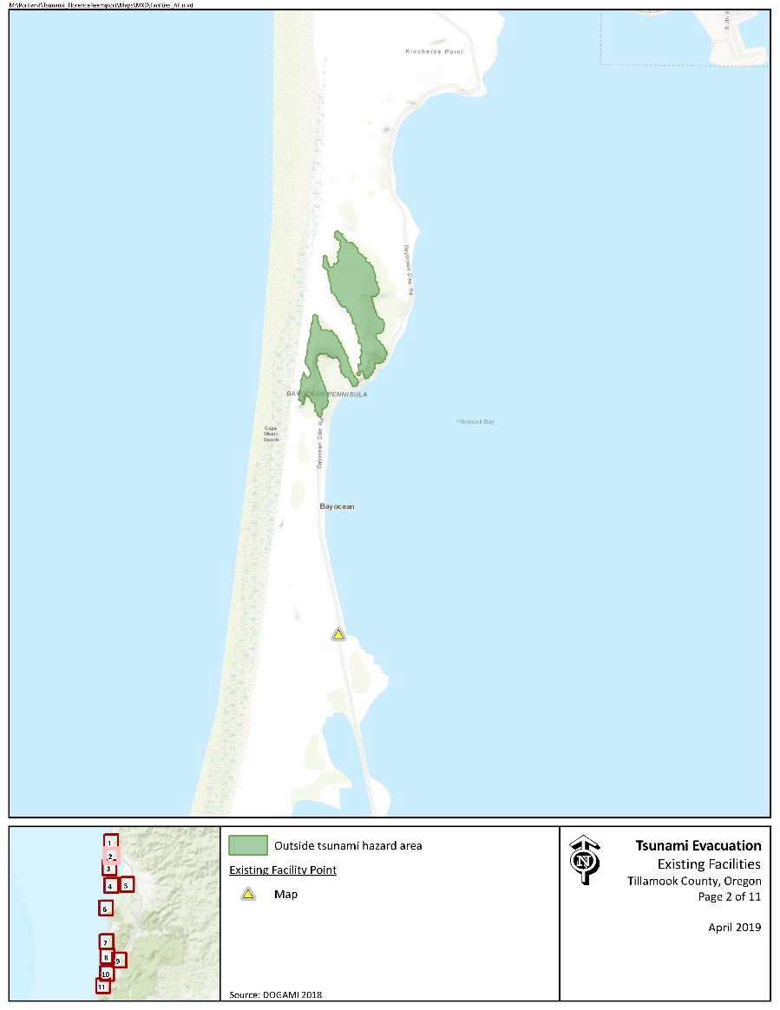

Figure 2 Existing Evacuation Signage – Cape Meares

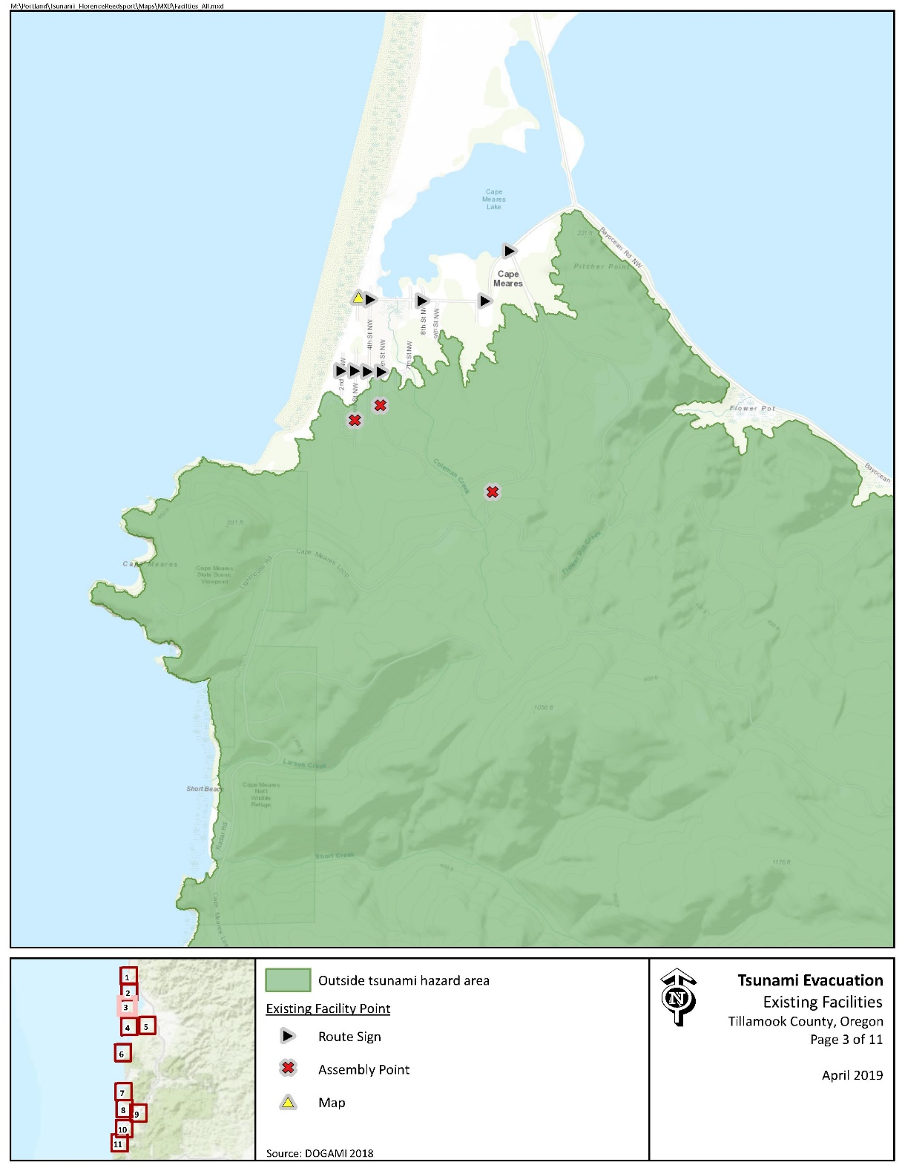

#### Evacuation Speeds

Evacuation speeds required to reach safety range from a slow walk and walk in much of the residential area in the southwest corner, though a fast walk is required in areas closer to the beach. In addition, run, sprint, and even unlikely to survive areas exist along Bayocean Rd along Tillamook Bay and in the northern extents of the spit.

Figure 3 Minimum Walking Speeds – Bayocean Spit

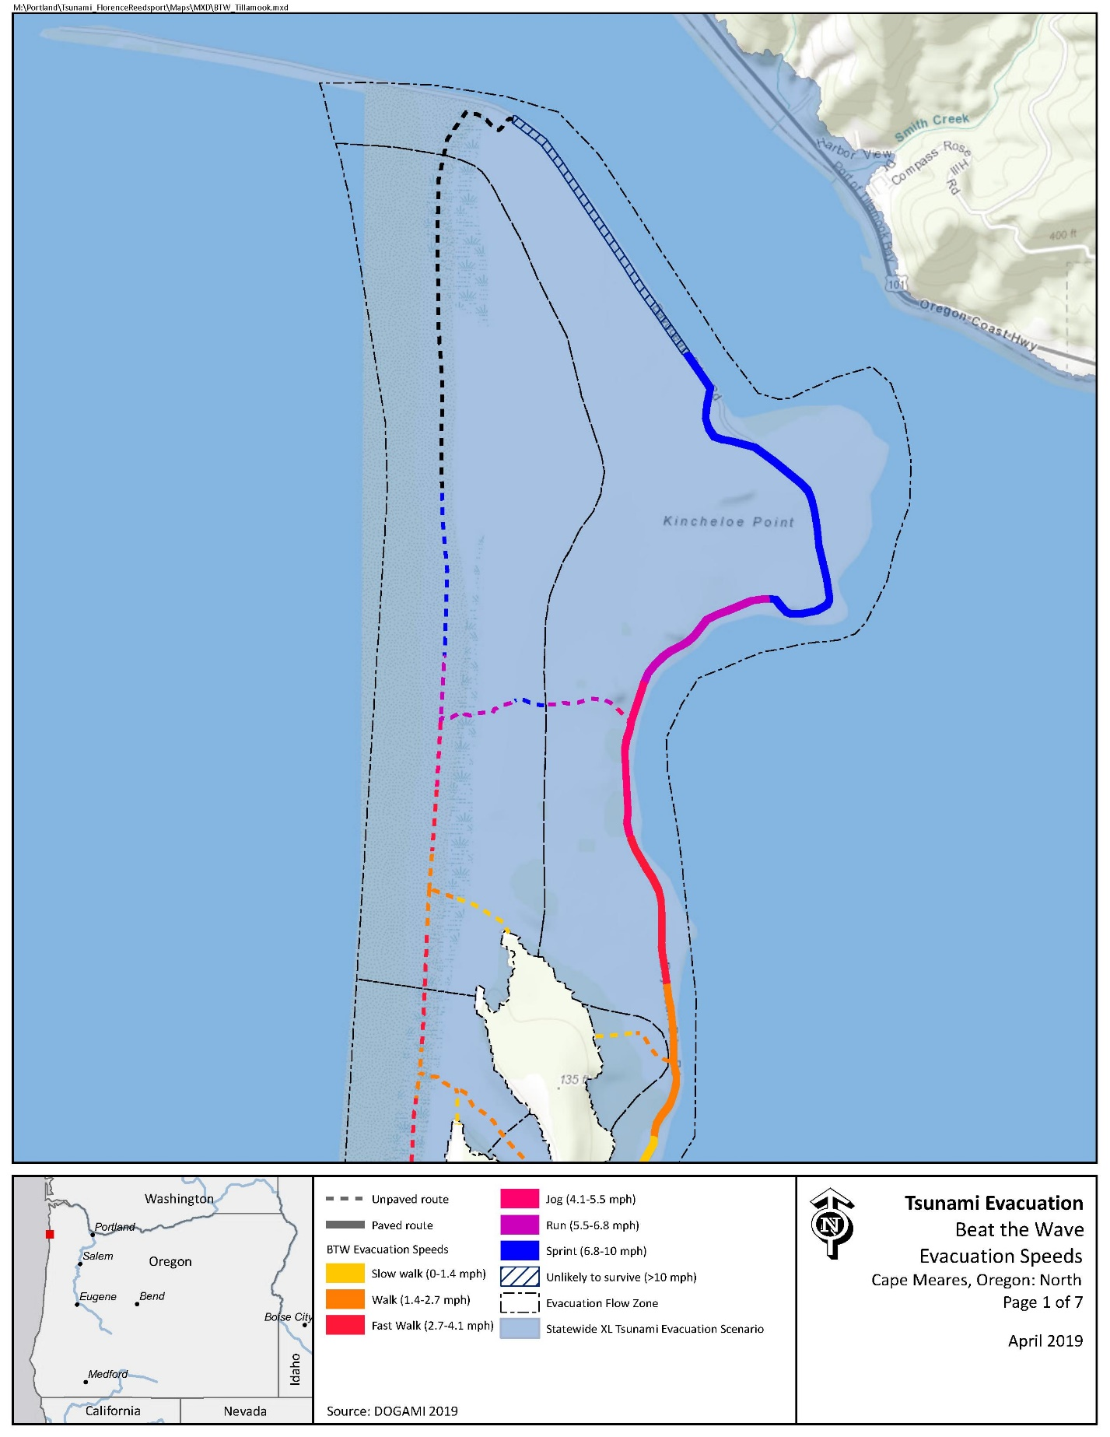

Figure 4 Minimum Walking Speeds – Cape Meares

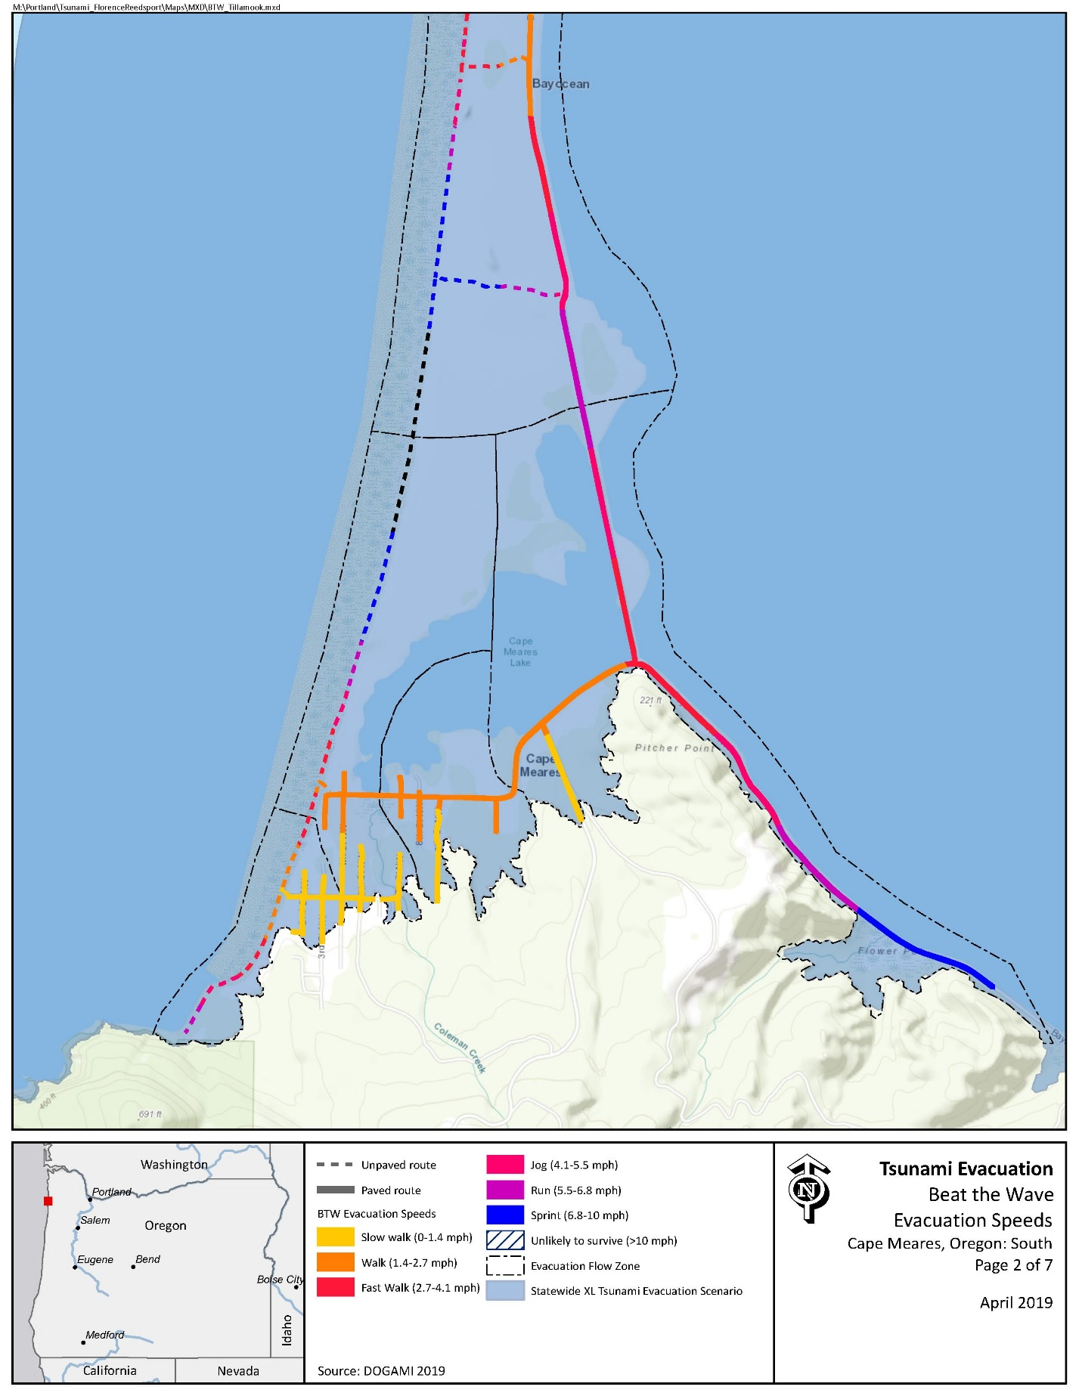

#### Critical Facilities

There are no critical facilities located within this area.

#### Conclusions

The residential area of Cape Meares is will marked with abundant evacuation routes. However, areas on Bayocean Rd along Tillamook Bay and much of the spit offer limited high ground. It is anticipated that relatively low numbers of individuals will be impacted in these areas, as no structures are within the inundation zone. Nonetheless, efforts should be taken to identify access to high ground and further educate residents and visitors.

# 3 Evacuation Improvements Project Identification

## 3.1 Wayfinding

#### The following wayfinding projects have been grouped together under a singular problem statement, as they all attempt to solve a similar issue.

Problem Statement: Limited existing signage and knowledge of priority evacuation routes may present difficulty to residents and visitors in evacuating from the inundation zone.

Prioritized Project Alternatives:

|  |  |  |  |  |  |  |
| --- | --- | --- | --- | --- | --- | --- |
| **Project ID** | **Type** | **Description** | **Location** | **Priority** | **Potential Project Partners** | **Estimated Cost** |
| 404 | Assembly Point | An effective Assembly Point location exists near the water tower on Cape Meares Loop at a lower elevation than existing Assembly Point signage. It is recommended that signage is placed in this location and considered for emergency cache storage. | [45.49792573, -123.9463039](https://www.google.com/maps/place/45%C2%B029'52.5%22N+123%C2%B056'46.7%22W/@45.4979294,-123.9484926,17z/data=!3m1!4b1!4m5!3m4!1s0x0:0x0!8m2!3d45.4979257!4d-123.9463039) | Medium | Local Property Owners, County Development Services | $60 per sign plus labor and installation costs |
| 408 | Blue Line | A trailhead exists at the southern extent of 2nd St and could be utilized as an evacuation route. It is recommended that a Blue Line or “Leaving Zone” sign is placed at the trailhead location. | [45.49671455, -123.9604829](https://www.google.com/maps/place/45%C2%B029'48.2%22N+123%C2%B057'37.7%22W/@45.4967183,-123.9626716,17z/data=!3m1!4b1!4m5!3m4!1s0x0:0x0!8m2!3d45.4967146!4d-123.9604829) | Medium | County Parks, County Community Development | $138.80 per Blue Line or $147 per aluminum sign plus labor and installation costs |
| 403 | Blue Line | Existing route sign along Cape Meares Loop exists directly at the inundation zone extent for an XXL event. It is recommended that the route sign be replaced by a Blue Line. | [45.50081238, -123.9463138](https://www.google.com/maps/place/45%C2%B030'02.9%22N+123%C2%B056'46.7%22W/@45.5008161,-123.9485025,17z/data=!3m1!4b1!4m5!3m4!1s0x0:0x0!8m2!3d45.5008124!4d-123.9463138) | Medium |
| 411 | Blue Line | Significant risk exists throughout the spit. It may be beneficial to place an “Entering Zone” sign heading north onto the spit. | [45.50676301, -123.9436883](https://www.google.com/maps/place/45%C2%B030'24.4%22N+123%C2%B056'37.3%22W/@45.5067667,-123.945877,17z/data=!3m1!4b1!4m5!3m4!1s0x0:0x0!8m2!3d45.506763!4d-123.9436883) | High |
| 807 | Route Sign | Overly redundant and confusing route signage exists in both directions Existing signage in both directions pointing toward 7th St. It is recommend that route signage should be moved to 6th St. | [45.49802985, -123.9564095](https://www.google.com/maps/place/45%C2%B029'52.9%22N+123%C2%B057'23.1%22W/@45.4980335,-123.9585982,17z/data=!3m1!4b1!4m5!3m4!1s0x0:0x0!8m2!3d45.4980298!4d-123.9564095) | Low | Tillamook County Parks  Tillamook County Parks, County Community Development, DLCD, DOGAMI | $61 per sign plus labor and installation costs |
| 401 | Route Sign | No existing route signs were discovered along Bayocean Rd along Tillamook Bay. While no high ground was discovered in this area, it is recommended that route signage be placed in intervals of ¼ mile directing evacuees toward Cape Meares Loop. | [45.5028384, -123.937997](https://www.google.com/maps/place/45%C2%B030'10.2%22N+123%C2%B056'16.8%22W/@45.5028421,-123.9401857,17z/data=!3m1!4b1!4m5!3m4!1s0x0:0x0!8m2!3d45.5028384!4d-123.937997) | High |
| 810 | Route Sign | No existing route signage exists at Bayocean Dike Rd and Bayocean Rd. It is recommended that a route sign be placed facing south, directly evacuees west toward Cape Meares Loop. | [45.50674645, -123.9437184](https://www.google.com/maps/place/45%C2%B030'24.3%22N+123%C2%B056'37.4%22W/@45.5067502,-123.9459071,17z/data=!3m1!4b1!4m5!3m4!1s0x0:0x0!8m2!3d45.5067465!4d-123.9437184) | High |
| 811 | Route Sign | A potential game trail was discovered within Bayocean Peninsula Park that would allow for access to high ground on the dunes. Trail enhancement it recommended in the Construction portion of this annex (See Project ID 812). In addition, it is recommended that route signage (small blue arrows) be placed along the existing spit trail system. Signage should be placed along County-owned land. Signs should be accompanied by guidance on the distance to high ground. | [45.52126392, -123.9477517](https://www.google.com/maps/place/45%C2%B031'16.6%22N+123%C2%B056'51.9%22W/@45.5212676,-123.9499404,17z/data=!3m1!4b1!4m5!3m4!1s0x0:0x0!8m2!3d45.5212639!4d-123.9477517) | High |
| 5203 | Map | Large portions of Bayocean Rd are within the inundation zone, with limited high ground. The most likely successful step to be taken would be the placement of a tsunami inundation zone map at the boat launch near Memaloose Point. | [45.52126392, -123.9477517](https://www.google.com/maps/place/45%C2%B028'17.0%22N+123%C2%B053'27.8%22W/@45.4713927,-123.8920329,245m/data=!3m2!1e3!4b1!4m14!1m7!3m6!1s0x0:0x0!2zNDXCsDMxJzE2LjYiTiAxMjPCsDU2JzUxLjkiVw!3b1!8m2!3d45.5212639!4d-123.9477517!3m5!1s0x0:0x0!7e2!8m2!3d45.4713907!4d-123.8910584) | Medium | Tillamook County Parks, County Community Development | $500 |

Potential Funding Sources: Wayfinding projects can often be implemented at minimal cost by utilizing existing, ineffectively-placed signage. However, the NOAA/NWS National Tsunami Hazard Mitigation Program (NTHMP) also provides grants to fund projects throughout coastal communities.

Project Beneficiaries: Wayfinding projects generally support all stakeholders in helping to promote an efficient evacuation process. In particular, residents and visitors benefit from the presence of maps and route signs to institutionalize knowledge.

## 3.2 Planning

|  |  |  |  |  |  |  |  |
| --- | --- | --- | --- | --- | --- | --- | --- |
| **Project ID** | **Description** | **Location** | **Priority** | **Potential Project Partners** | **Potential Funding Sources** | **Estimated Cost** | **Project**  **Beneficiaries** |
| 413 | (Associated with Project 812) It is recommended that the County consider placement of emergency caches in this location to allow for long-term emergency shelter on Bayocean Spit. | [45.534278, -123.950212](https://www.google.com/maps/place/45%C2%B032'03.4%22N+123%C2%B057'00.8%22W/@45.5342817,-123.9524007,17z/data=!3m1!4b1!4m5!3m4!1s0x0:0x0!8m2!3d45.534278!4d-123.950212) | High | County Parks, County Community Development, Recreational Groups | EMPG, Local funding, in-kind supply donations | $1,000 | Visitors |

## 3.3 Construction

|  |  |  |  |  |  |  |  |  |
| --- | --- | --- | --- | --- | --- | --- | --- | --- |
| **Project ID** | **Type** | **Description** | **Location** | **Priority** | **Potential Project Partners** | **Potential Funding Sources** | **Estimated Cost** | **Project**  **Beneficiaries** |
| 809 | Vertical Evacuation – Staircase | Bayocean Rd/ 12th St at the bend near 12 St offers a location for a potential staircase to lead toward Cape Meares Loop. This may offer minimal evacuation support but does provide co-benefits for safe pedestrian travel. | [45.50168, -123.950011](https://www.google.com/maps/place/45%C2%B030'06.1%22N+123%C2%B057'00.0%22W/@45.5016837,-123.9521997,17z/data=!3m1!4b1!4m5!3m4!1s0x0:0x0!8m2!3d45.50168!4d-123.950011) | Low | County Community Development, County Parks | Internal funding, NTHMP, FEMA HMA | $15,000 | Recreational visitors |
| 413 | Vertical Evacuation – Structure | The northern extent of Bayocean Spit has minimal high ground within survivable distances. While this is a lowly traveled portion of the spit, the community may want to consider the placement of a vertical evacuation shelter that also provides co-benefits for recreational use. | [45.557614, -123.94565](https://www.google.com/maps/place/45%C2%B033'27.4%22N+123%C2%B056'44.4%22W/@45.5576177,-123.9478437,17z/data=!3m1!4b1!4m5!3m4!1s0x0:0x0!8m2!3d45.557614!4d-123.945655) | Low | County Community Development, County Parks | NTHMP, FEMA HMA | $2.5 million |
| 812 | Trail Enhancement | An existing game trail exists within Bayocean Peninsula Park, but requires significant enhancement and maintenance to allow for safe passage to high ground. | [45.533329, -123.94926](https://www.google.com/maps/search/45.533329,+-123.94926?sa=X&ved=2ahUKEwiDsLj6l_viAhVBvlkKHaaYDrwQ8gEwAHoECAoQAQ) | High | County Community Development, County Parks | Internal funding, NTHMP, FEMA HMA | Minimal – county labor and equipment; potential need for further engineering studies |

Problem Statement: Areas within Bayocean Peninsula Park and the Cape Meares Spit are characterized by long distances to reach high ground. Therefore, the community may want to consider construction projects to allow residents and visitors to access high ground more quickly. It should be noted that any construction-related projects should also be accompanied by signage improvements to ensure vertical evacuation locations are well-socialized.

Prioritized Project Alternatives:

1. ...