Community Annex E Netarts
1 Community Overview 2
2 Existing Evacuation Facilities Analysis 2
3 Evacuation Improvements Project Identification 6
3.1 Wayfinding 6
3.2 Planning 7
3.3 Construction 7

1 Community Overview
The Netarts community sits along the coastline of the Pacific Ocean directly south of Oceanside and north of Cape Lookout State Park. The are has a mix of residential, commercial, and recreational uses within the inundation zone.

2 Existing Evacuation Facilities Analysis

Tsunami Wave Arrival Time
In the XXL scenario, waves will begin to arrive at the beach in approximately 25 minutes after the earthquake begins. The wave crosses the area fairly uniformly from west to east, while southern portions of Netarts, within Netarts Bay will see wave arrival times in approximately 25-30 minutes. Waves will continue to inundate stream valleys throughout the area, with the easternmost extents experiencing waves within 35 minutes.
See Appendix B for maps.

Existing Evacuations Routes and Signage
The TEFIP relies on the presence of existing infrastructure and signage to inform improvement planning. While most of the existing signage is accurate, several communities have infrastructure and signage that is either inaccurate or requiring enhancement. The area has existing signage at the following locations (see Figure 1 for location of signs plotted on map):
Type | Description | Location
Blue Line | Existing “Entering Zone” sign on north end of town south of Happy Camp Rd heading north. | 45.43863, -123.95
 | Existing “Entering/Leaving Zone” sign (two signs) on Netarts Highway west of Deer Ridge Rd. | 45.44152, -123.888
Route Sign | Existing route sign on Netarts Highway pointing north onto Ocean Highlands Pkwy. | 45.42969, -123.935
 | Existing route sign on Netarts Highway pointing east onto Holly Heights Ave. | 45.43523, -123.946
 | Existing route sign on Netarts Highway pointing east onto Phelps Ave. | 45.43678, -123.947
 | Existing route sign pointing south on Happy Camp Rd onto Netarts Highway. | 45.43854, -123.95
Vertical Evacuation | Existing dune hill near Netarts Highway that could serve as vertical evacuation route to high ground. | 45.44121, -123.957

Figure 1 Existing Evacuation Signage
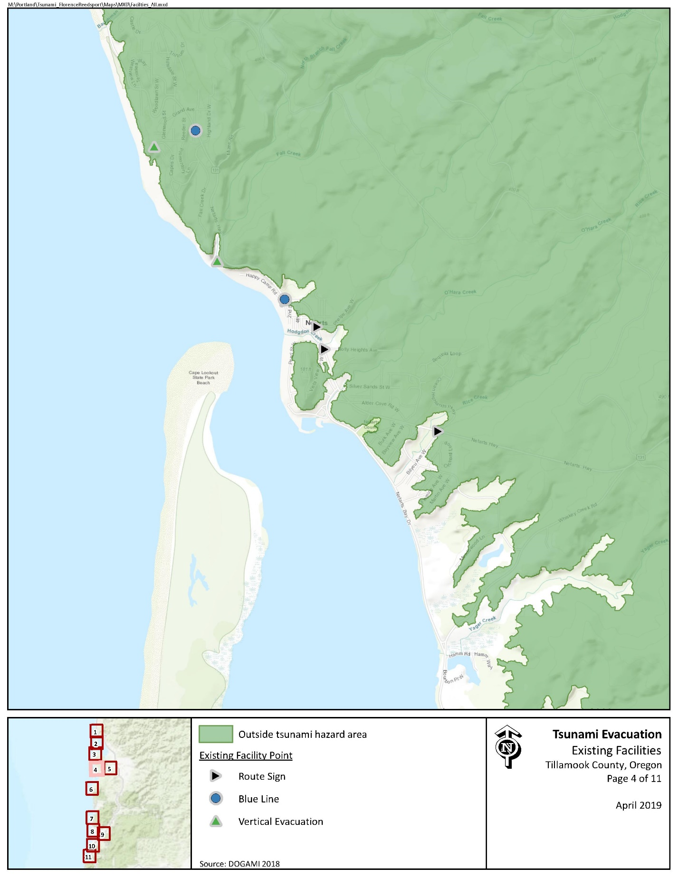

Evacuation Speeds
Evacuation speeds required to reach safety range from a slow walk to walk in much of Netarts. Evacuation speeds along Whiskey Creek Rd along Netarts Bay may require a fast walk in the central vicinity.

Figure 2 Minimum Walking Speeds
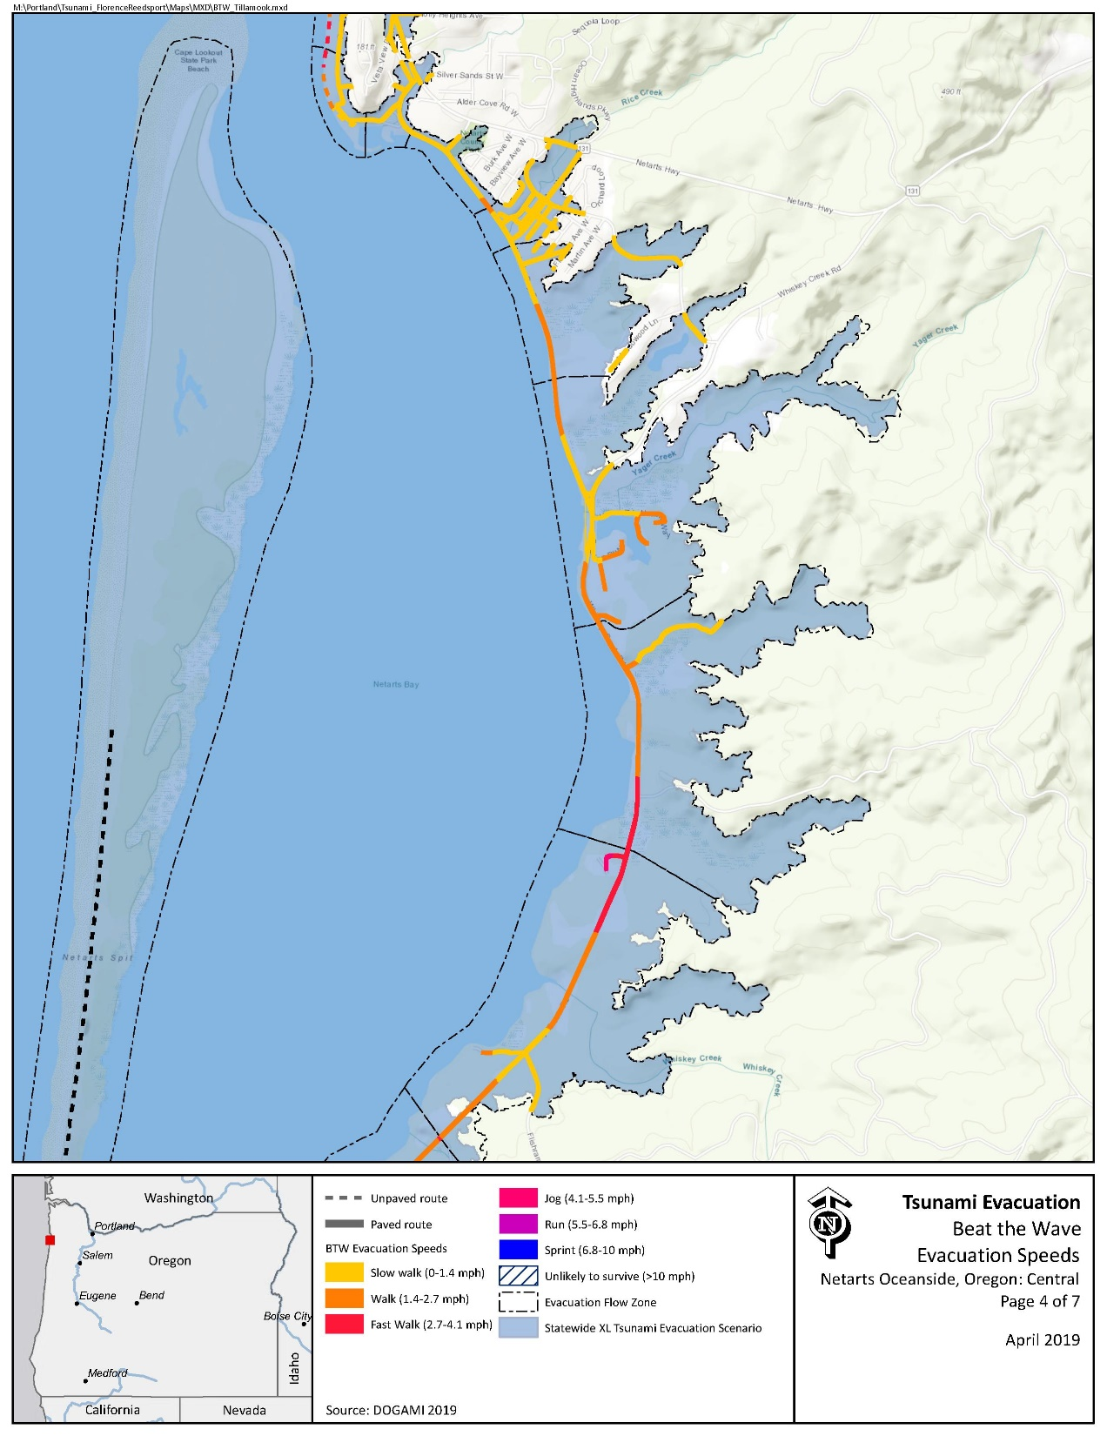

Critical Facilities
No critical facilities exist within the inundation zone.

Conclusions
The Netarts community benefits from relatively ample high ground, which require relatively slow evacuation speeds. However, large swaths of area reside within the inundation zone and the community would benefit from added wayfinding investments.

3 Evacuation Improvements Project Identification

3.1 Wayfinding

The following wayfinding projects have been grouped together under a singular problem statement, as they all attempt to solve a similar issue.
Problem Statement: Limited existing signage and knowledge of priority evacuation routes may present difficulty to residents and visitors in evacuating from the inundation zone.
Prioritized Project Alternatives:
Project ID | Type | Description | Location | Priority | Potential Project Partners | Estimated Cost
416 | Blue Line | Recommended Blue Line or “Leaving/Entering Zone” sign on Whiskey Creek Rd just east of Netarts Bay Dr. This is a heavily trafficked area and would present a highly visible location. | 45.41642246, -123.9327669 | High |  | $138.80 per Blue Line or $147 per aluminum sign plus labor and installation costs
819 | Blue Line | Recommended Blue Line or “Leaving/Entering Zone” sign on Netarts Hwy south of Crab Ave. | 45.43743154, -123.9471865 | High
417 | Map | Netarts Bay Dr north of Whiskey Creek Rd is a popular walking area and is largely within the XXL inundation zone. It is recommended that a map be placed near this location to improve awareness and education. | 45.4231056, -123.9374132 | Medium |  | $500 per sign
419 | Map | Recommend tsunami inundation zone map placed in boat launch parking lot to improve awareness and education. | 45.43061267, -123.9465301 | High
816 | Map | Much of western Pearl St is within the inundation zone but given its elevation gains, there may be a misperception that the road is outside of the inundation zone. It is recommended a map or Blue Line be placed in this area to provide additional clarity. | 45.43323807, -123.9494207 | Medium
818 | Map | Recommend tsunami inundation zone map at beach access at Crab Ave and 2nd St. | 45.43738418, -123.9497172 | Low
5204 | Map | Recommended tsunami inundation zone map at beach access on Whiskey Creek Rd near Hamm Rd. | 45.412791, -123.934418 | Medium
418 | Route Sign | Recommended route sign placed on Netarts Bay Dr pointing north onto Park Ave. | 45.42952668, -123.9428773 | Medium |  | $61 per sign plus labor and installation costs

Potential Funding Sources: Wayfinding projects can often be implemented at minimal cost by utilizing existing, ineffectively-placed signage. However, the NOAA/NWS National Tsunami Hazard Mitigation Program (NTHMP) also provides grants to fund projects throughout coastal communities.
Project Beneficiaries: Wayfinding projects generally support all stakeholders in helping to promote an efficient evacuation process. In particular, residents and visitors benefit from the presence of maps and route signs to institutionalize knowledge.

3.2 Construction
Project ID | Type | Description | Location | Priority | Potential Project Partners | Potential Funding Sources | Estimated Cost
2001 | Trail Enhancement/ Staircase Construction | The area surrounding the boat launch on Netarts Blvd presents large swaths of area within the inundation zone. High ground exists north of southern extent of Netarts Blvd toward Vista View Dr. It is recommended the community consider developing a trail and/or staircase installation to allow access from the boat launch to high ground. | 45.430936, -123.947581 | Medium | Local property owners, County Community Development, County Public Works, DLCD, DOGAMI | Recreational Trail Program, Trails Unlimited | Minimal for trail enhancement with volunteer support/$15,000 for staircase installation

