
Tillamook County Public Works
503 Marolf Loop Road, Tillamook, OR 97141
County Road Phone: 503-842-3419
TTY Oregon Relay Service

_____________________________________________________________

Land of Trees, Cheese, and Ocean Breeze

TILLAMOOK COUNTY PUBLIC WORKS

COUNTY ROAD ADVISORY COMMITTEE MEETING (CRAC)

AGENDA
Monday, February 3rd, 2025
3:00 PM TO 5:00 PM

Click here to join the meeting
Or call in (audio only) 1-971-254-3149 Phone Conference ID: 247 872 498#

- Call Meeting to Order
- Review and Approve December 2nd, 2024, Meeting Minutes
- Helpful Links:
- http://tillamook.streetpixweb.com/
- Local Access Road information

- Public Comment:
- Paving LAR 4th Street in Pacific City – Becky Voorhies
- LAR support for Cascade Trace Roads – Cynthia Tinoco
- LAR support for Ridge View Way – Debbie Iseri

- Admin & Operations:
- Human Resources Director
- AFSCME Bargaining
- Staffing
- Schedule
- Vehicles/Equipment
- Fleet Service
- Road Employee Safety Team
- Deicing
- Blaine Culvert (28-ft bridge beams)

Budget

- ODOT Projections
- Winter Storms
- Paving List (Late February)

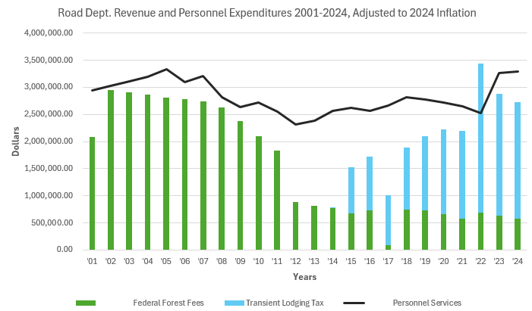

Number of vacation rental businesses are capped. A year over year shows an increase in revenue; the revenue is lost due to inflation.

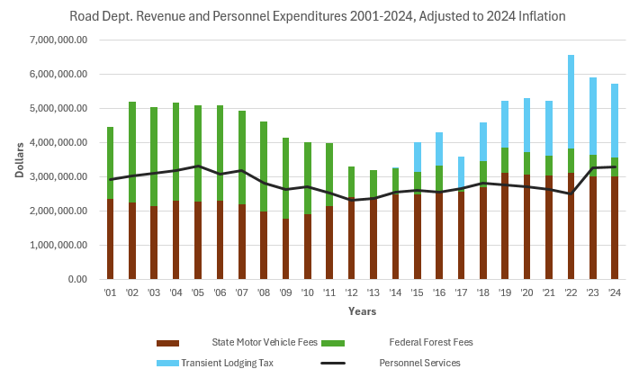

State Gas Tax increased $0.40 from HB 2017. Has not kept up with inflation. Revenue is expected to stay the same, a decline after inflation.

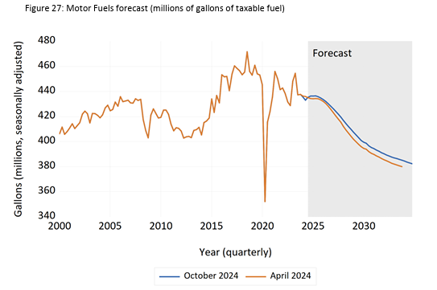

Current model of funding roads & bridges is not sustainable. ODOT State Transportation Revenue Forecast. State legislature is reviewing options to increase revenue. Counties receive 30% of the gas tax based on the number of registed vehilces in the county.

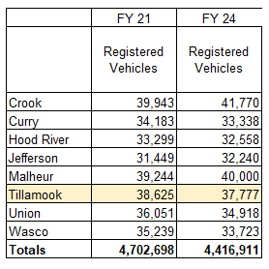

Registered vehicles are decreasing compounding the problem.
Paving

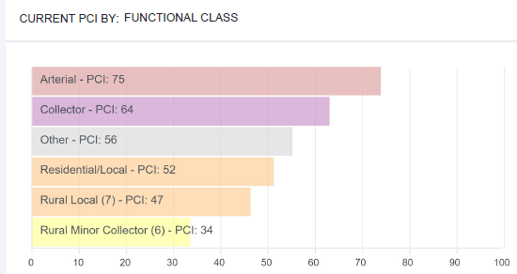

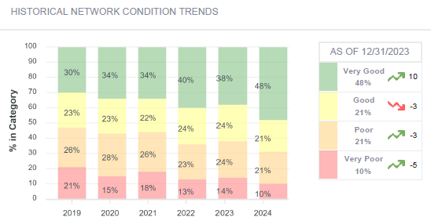

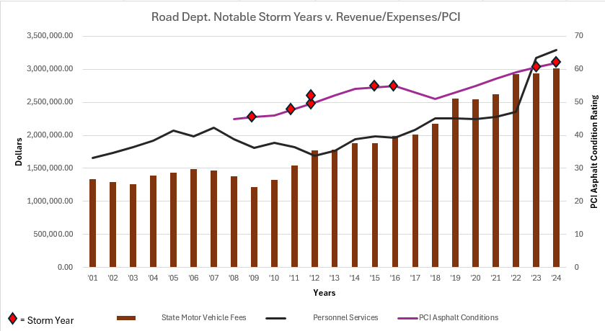
Projects (To be discussed if additional information is needed)
Note: FWHA emergency projects are 100% reimbursed, 10% match for permanent repair
ODOT has a 10% match.
FHWA AOP projects have a 20% match
FEMA projects are reimbursed at 75% (25% match)
SSH matches vary, Flowerpot Culvert to Bridge has $0 cash match
TCPW is 100% funded by the Road Department

- December 2015 FEMA/FHWA Declaration Update
- 2024 FHWA: Dick Creek Bridge
- 2025 FHWA: Dry Creek Bridge
- 2025 FHWA: Crystal Creek Bridge
- 2025 FEMA: Hadley Road – Alternate Project
- 2025 FEMA: Kilchis House Drainage Project
- 2025 FEMA: East Creek Retaining Wall

- December 2023 FHWA Declaration Update
- 2025 FHWA/ODOT Crystal Creek Bridge
- 2026 FHWA/ODOT Sandlake Road Slide

- January 2024 FEMA Declaration Update
- 2024 Big Trout Bridge – Temporary bridge installed
- 2025 FEMA FMA Grant

- Construction 2025
- 2025 ODOT Dry, Crystal Creek Bridges
- 2025 TCPW Lagler Bridge (Closure & Crystal Creek Beams)
- 2025 TCPW: Sloan Bridge (Slab Creek Road) Repair
- 2025 TCPW: Prospect Bridge (Slab Creek Road) Repair
- 2025 SSH Flowerpot Creek Bridge (Bayocean Road)
- 2025 SSH USFS Enterprise Team: Esther Creek (Tomlinson Road)
- 2025 FEMA: Kilchis House Drainage Project
- 2025 FEMA: East Creek Retaining Wall
- 2025 SSH: Myrtle Creek (Kilchis River Road)
- 2025 USFS (asphalt)/TCPW (labor & equip) Paving Cedar Creek Road
- 2025 TCPW (asphalt)/Neskowin (labor & equip) Misc. Road paving
- 2025 TCPW: Winema Road Contract Paving

- In-Design:
- TCPW: Misc. Guardrail work around the County
- TCPW Bike/Ped: Short Beach Trail w/ Trail Keepers of Oregon
- ODOT: Prince Bridge (Blum Lane)
- ODOT: Atkinson Bridge (Sandlake Road)
- BOCC: Wilson River Revetment (Shilo Levee)
- SSH/TEP: Reneke Creek (Sandlake Road)
- SSH/TU: Hatchery Creek (Trask River Road)
- TCPW: Burton Creek (Trask River Road)
- SSH USFS Enterprise: Davis Creek (Cape Lookout Road)
- SSH USFS Enterprise: Slick Rock (Upper Nestucca Road,
- SSH USFS Enterprise: Bower Trib. (Meda Loop)
- SSH USFS Enterprise: Un-named Trib (Irish Road).
- SSH: Beaver Creek (Sollie Smith Road)
- SSH: Slide Creek (Latimer Road)
- SSH/USFS Enterprise Team + two more in review
- TCPW: Jim Creek Bridge (Slab Creek Road) Eval
- TCPW: Lewis Creek Bridge (Slab Creek Road) Eval
- TCPW: Hushbeck Bridge (Learned Road) Eval
- TCPW: Browning Bridge (Powder Creek Road) Eval

- Request for Proposals/Contracting:
- TCPW/FHWA AOP Mill Creek & Mill Creek Trib. B (Brickyard Road)
- Foss Road Bank Stabilization (Exploratory Memo Results)

- Planning
- TCPW: Nehalem Quarry Expansion
- TCPW: Ridge Road Local Improvement District.
- ODOT: Transportation System Plan
- Reviewing Grants for Holden Creek
- Foss Road culvert using remaining Crystal Creek Beams
- ODOT: Cloverdale Transportation

- Areas of Concern
- Curl Bridge
- FEMA Biological Opinion
- Grant Funding

- Funding
- General Obligation Bond

- Miscellaneous
- Short Term Rental – On Street Parking Verification
- County Budget
- Other

- Adjourn

