FEMA PUBLIC ASSISTANCE

PNP PROGRAM SUMMARY GUIDANCE

Private Non Profit (PNP) Organizations
PNP organizations or institutions that own or operate facilities that provide certain services otherwise performed by a government agency are eligible for assistance. These organizations, their facilities and services must meet additional eligibility criteria beyond that which apply to governmental type applicants. (See FEMA Public Assistance Program and Policy Guide, page 15)

In order to be eligible for public assistance, PNP organizations are required by law and regulation to provide certain types of services and to follow special procedures. PNP organizations must have an effective ruling letter from the U.S. Internal Revenue Service granting tax exemption or certification from the State that the organization is a non-revenue producing, nonprofit entity organized or doing business under State law.

To be eligible for assistance, the primary purpose of a PNP must be to provide a public service that is not restricted by a specific definition or by prohibitive fees. If access to the use of PNP services is restricted, the PNP is not eligible. (For eligible and not eligible PNP facilities see table below).

Application Requirements for PNPs

Emergency Work. All PNPs that are eligible for FEMA assistance, as described above and in 44 CFR 206.221(e), may apply directly to FEMA for emergency assistance under 44 CFR 206.225.

Permanent Work. Eligible PNPs seeking reimbursement for permanent repairs and restoration from FEMA may apply for disaster assistance according to the following requirements, depending on whether they are deemed “critical” or “Essential” PNPs by the Stafford Act:

- Critical PNPs are defined in the Stafford Act as those providing power, water, sewer and wastewater, communications, emergency medical, fire protection, emergency services and educational. Critical PNPs may apply directly to FEMA for permanent repair and restoration assistance. All other PNPs are considered “Essential” and must follow the application process described below.

- Essential PNP services are those eligible organizations that do not qualify as critical service facilities. Essential PNPs must first apply to the Small Business Administration (SBA) for a low-interest loan for repair of disaster damages.
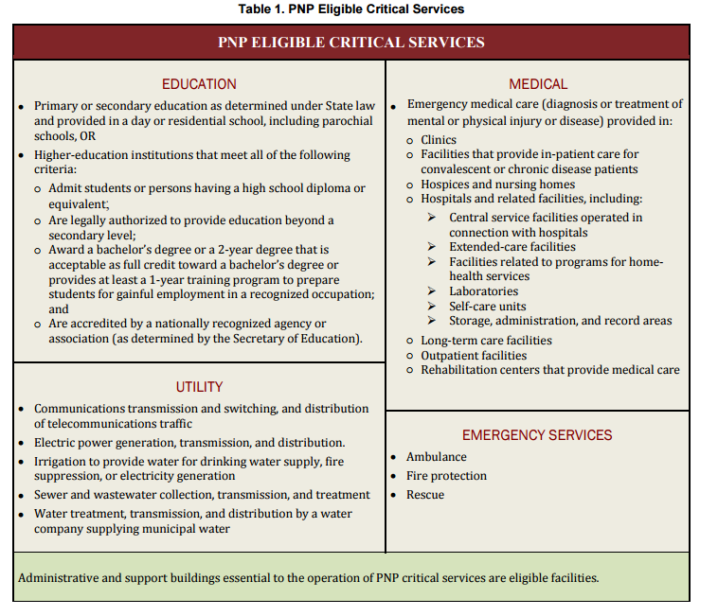

PNP ELIGIBLE NON-CRITICAL, ESSENTIAL GOVERNMENTAL-TYPE SERVICES
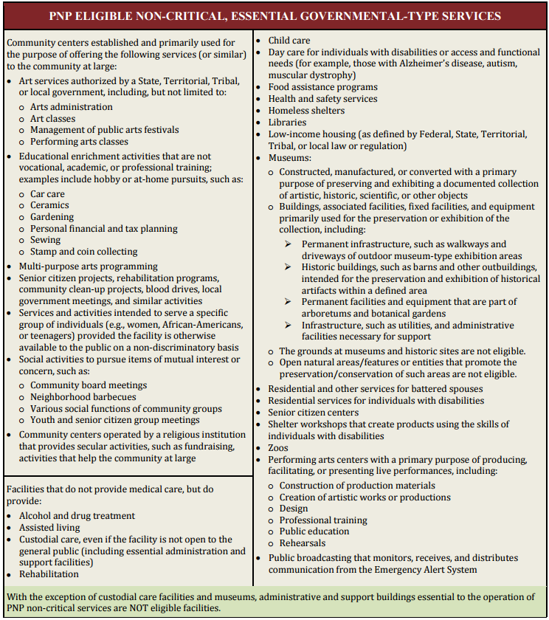

For further information see link below for relevant policies and fact sheets:
http://www.fema.gov/public-assistance-policy-and-guidance

